Michael Chizy, Chairman  John L. Hebert, Vice Chairman  Richard Hersom, Clerk  Ryan Fattman  Kevin Geraghty  James A. Smith, Town Administrator | 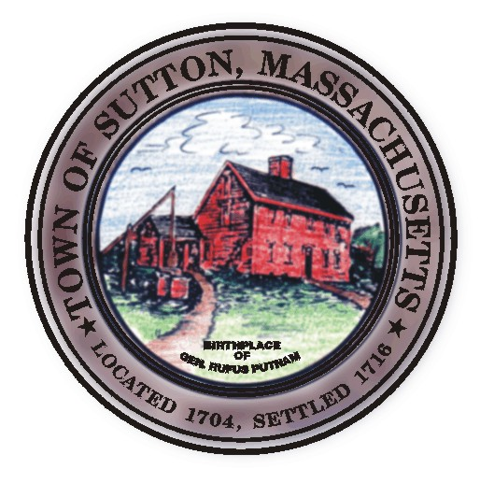 | Sutton Town Hall  4 Uxbridge Road  Sutton, Massachusetts 01590  (508) 865-8727  Fax: (508) 865-8721
Town Of Sutton
Board Of Selectmen

Meeting Agenda

7:00 p.m. – Tuesday November 18, 2008

Sutton Town Hall, Selectmen’s Meeting Room

- Call to Order, Pledge of Allegiance at 7:00 p.m.

- Public Forum: Limited to 5 minutes per topic. Discussion or comments about town employees or agency members shall be avoided so as not to violate individual’s rights.

- Minutes

  - Board of Selectmen minutes from 10/28/2008 & 11/04/2008

- Sponsored Agenda and Action Items

2. Appointment of Police Officers
3. Holiday Opening Schedule for ALL Alcohol License holders
- Treas/Collec Cheryl Ouillette requests Selectmen’s approval to borrow $509,250.00 to fund FY09 Capitol Plan
- Review of Blackstone Valley Regional Economic Development Council participation agreement
6. Financial discussion FY08 year end & FY10 preliminary financial discussion

V. Town Administrator Update
VI. Announcements
VII. Selectman’s Roundtable: Correspondence and Business Topics

Adjournment

